Brown Lace designs esimatiom

Des | Semi-Personal | Personal
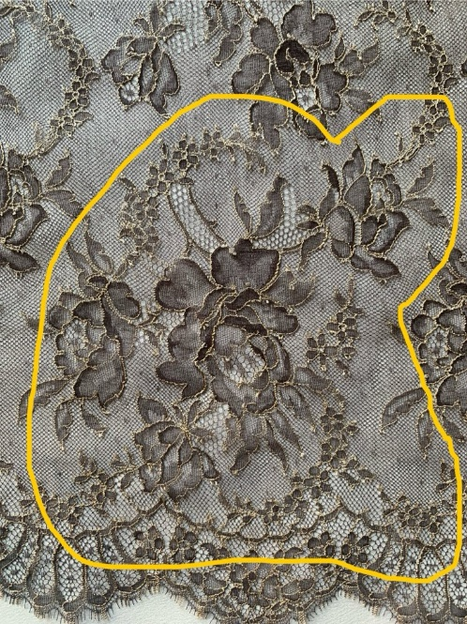  10x10” ( Split into 2 parts?) | 120 | 250
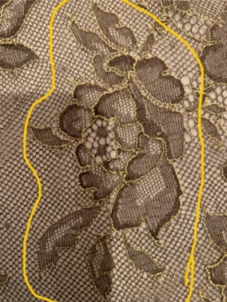 | 10 | 30
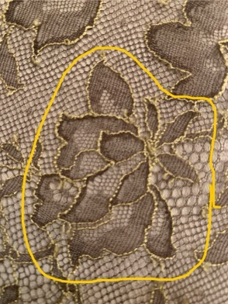 | 10 | 30
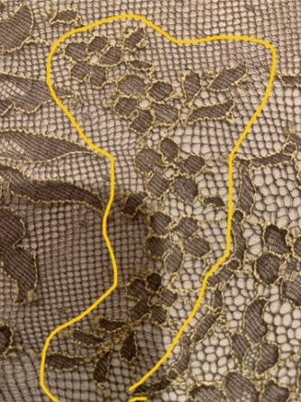 | 10 | 30
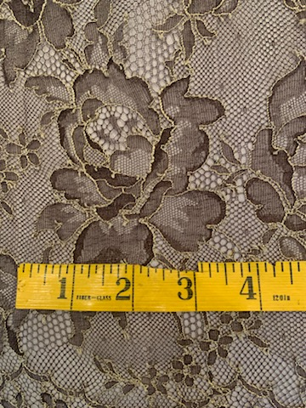 | 10 | 30
Border  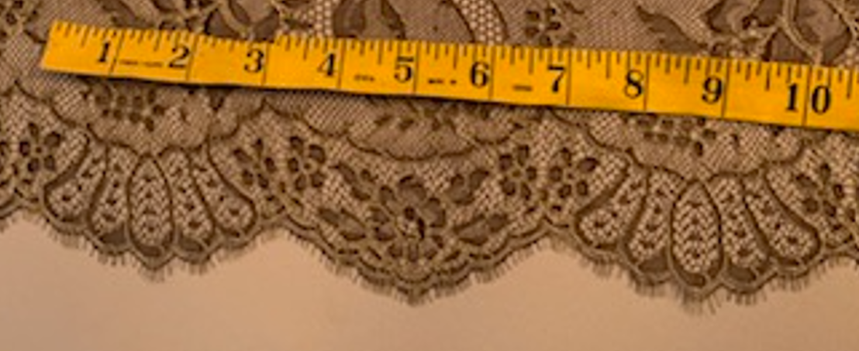 | 65 | 140

